**SIPI Team was ranked 3rd in NASA Swarmathon National Competition**

The TECHLAV sponsored team members of SIPI for being ranked 3rd among 12 competing teams in NASA Swarmathon National Physical Competition held at the NASA Kennedy Space Center, in Florida, on April 20 and 21, 2016. SIPI team comprised of Brian Bedonie, Sasha Benallie, Daron Tewa, Bradley Kaye, and Emery Sutherland. The team faculty advisors were Dr. Nader Vadiee and Mr. Jonathan West. Students were challenged to develop search algorithms for robotic swarms.

[SIPI Swarmathon 2016](https://youtu.be/k2EL4v-1NQs)

[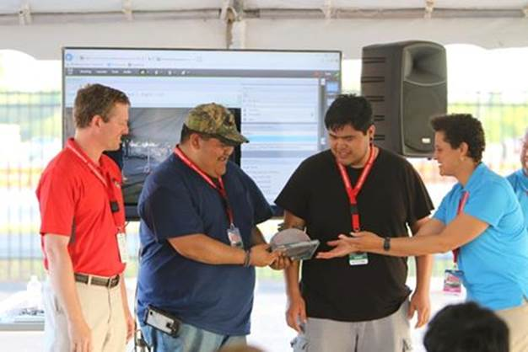](https://www.facebook.com/339779393318/photos/pcb.10154232374783319/10154232374038319/?type=3)

[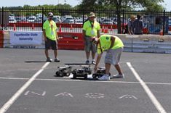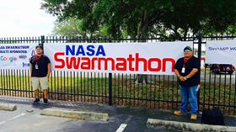](https://www.facebook.com/339779393318/photos/pcb.10154232374783319/10154232374418319/?type=3)